PARTNERS FOR ADVANCED TRANSPORTATION TECHNOLOGY
INSTITUTE OF TRANSPORTATION STUDIES
UNIVERSITY OF CALIFORNIA, BERKELEY

Connected Corridors I-210 Pilot

Technical Overview of the Cell Transmission Model (CTM)

July 15, 2015

Partners for Advanced Transportation Technology works with researchers, practitioners, and industry to implement transportation research and innovation, including products and services that improve the efficiency, safety, and security of the transportation system.
Primary Author

Anthony D Patire, PhD
Research and Development Engineer
California PATH
University of California, Berkeley

Contributing Authors

Joe Butler
Project Manager
California PATH
University of California, Berkeley
Ethan Xuan, PhD
Research Engineer
California PATH
University of California, Berkeley
Thomas Schreiter, PhD
Research Engineer
California PATH
University of California, Berkeley
Gabriel Gomes, PhD
Research Engineer
California PATH
University of California, Berkeley
Francois Dion, PhD, PE (Michigan)
Senior Development Engineer
California PATH
University of California, Berkeley
Paul Gabet, MS
Graduate Student Researcher
California PATH
University of California, Berkeley

Fred Winik
Technical Writer
California PATH
University of California, Berkeley

Technical overview of the cell transmission model (CTM)
This technical overview briefly describes the following elements of the Cell Transmission Model (CTM):

- Fundamental diagram  - Godunov Scheme for a chain of links  - Node model | - Signalized intersections  - Ramp meters  - Performance measures
For a complete description of the model, see “Active Traffic Management on Road Networks: A Macroscopic Approach” at http://ccdocs.berkeley.edu/filedepot_download/687/214.

Cell Transmission Model
The Cell Transmission Model is a discretized version of the well-known Lighthill-Whitham-Richards (LWR) model. The network is discretized into links which are connected via nodes; each link is of size $ΔX_{i}$ (index $i$ is used to denote a specific link). Time is discretized into steps of length $ΔT$ (index $j$ is used to denote a specific time step). The discretization scheme is known as the Godunov Scheme.
Technical Note: In order to ensure numerical stability, the time and space steps are coupled by the CFL condition:
$$\frac{ΔT}{ΔX_{i}}≤\frac{1}{v_{ff,{i}}}$$
where $v_{ff,{i}}$ denotes the free flow speed for link $i$ according to the fundamental diagram.

The fundamental diagram
For each link $i$, a fundamental diagram $Q_{i}$($ρ$) is defined, which relates the flow and the density $ρ$:
$$Q_{i}(ρ)=\left\{\begin{matrix}v_{ff.{i }}⋅ρ & \operatorname{if}{ } & ρ≤ρ_{crit,{i}} \\ -w_{i}⋅\left(ρ-ρ_{jam,{i }}\right) & \operatorname{if}{ } & \operatorname{else}{ }\end{matrix}\right.$$
Three parameters are sufficient to specify uniquely a triangular fundamental diagram. The following list describes physical interpretations of parameters that are commonly used.
$v_{ff,{i}}$ free-flow speed, i.e., speed of traffic in light conditions
$ρ_{crit,{i}}$ critical density, i.e., density when flow is at capacity
$q_{cap,{i}}{=v}_{ff,{i}}⋅ρ_{crit,{i}}$ capacity, i.e., maximum possible flow (also called saturation flow)
$w_{i}$ wave speed (in congestion), i.e., speed of shock waves in congestion
$ρ_{jam,{i}}$ jam density, i.e., density when traffic is standing still

The Godunov Scheme for a chain of links
The traffic state in the network is represented by the traffic density $ρ_{i}^{j}$. The following equations show how traffic evolves over a chain of links, i.e., two links are connected by a simple 1-to-1 node. More complicated cases, which are relevant to modeling on-ramps, off-ramps, and intersections, are outlined below. Density evolves over time according to the conservation of vehicles:
$$ρ_{i}^{j+1}=ρ_{i}^{j}-\frac{ΔT}{ΔX_{i}}\left(f_{i→i+1}^{j}-f_{i-1→i}^{j}\right)$$
Where $f_{i→i+1}^{j}$is the flow (or flux) between two neighboring links (index $i$ is increasing with direction of traffic). The flux depends on the demand of the upstream link and the supply of the downstream link:
$$f_{i→i+1}^{j}=\min{\{d_{i}^{j}, s_{i+1}^{j}\}}$$
Demand and supply are defined by the fundamental diagram and the current density:
$$d_{i}^{j}=\left\{\begin{matrix}Q_{i}(ρ_{i}^{j}) & if & ρ_{i}^{j}≤ρ_{crit,{i}} \\ q_{cap,{i}} & if & \operatorname{else}{ }\end{matrix}\right.$$
$$s_{i}^{j}=\left\{\begin{matrix}q_{cap,{i}} & \operatorname{if}{ } & ρ_{i}^{j}≤ρ_{crit,{i}} \\ Q_{i}(ρ_{i}^{j}) & \operatorname{if}{ } & \operatorname{else}{ }\end{matrix}\right.$$

The node model
This section briefly outlines how traffic flows when more than two links (or cells) are connected via a node. On freeways, this occurs at on-ramps (2-to-1 nodes) and at off-ramps (1-to-2 nodes), as shown in Figure 1:
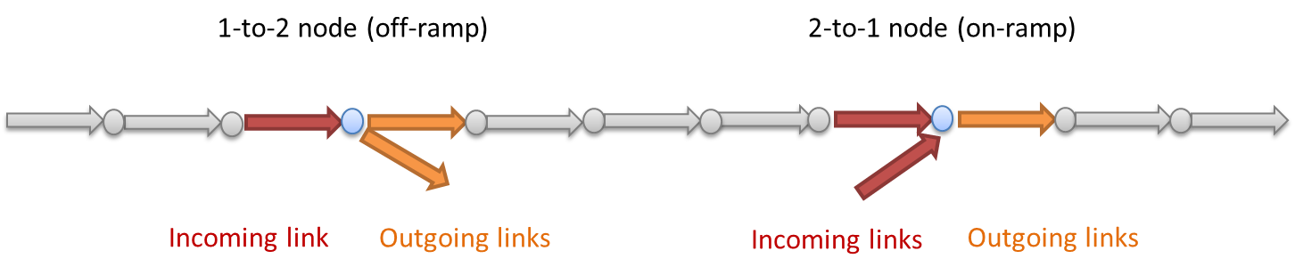
Figure 1: Node types at freeway ramps: 2-to-1 and 1-to-2
Two-to-one nodes are used to model merges such as on-ramps. To determine the fluxes at the node, the supply of the outgoing link is distributed to the incoming links according to their capacities. If one in-link’s demand is completely served (i.e., its demand is lower than its allocated supply), it provides its excess supply to the other incoming link.
One-to-two nodes are used to model diverges such as off-ramps. The split ratios, or turning ratios, define the fraction of incoming traffic destined to leave the freeway at the off-ramp. To determine the fluxes between the incoming and outgoing links, the demand of the incoming link is distributed according to the specified split ratio. If one of the outgoing links is congested, the flux into the other link is reduced to reflect the (partial) blockage of an off-ramp.
At arterials, the topology is more complicated, which leads to many-to-many nodes. The assumptions and ideas of the simple node types can be combined to general nodes. The equations for general nodes are not shown here, but the overall procedure is as follows:
- Compute supply for each out-link (total amount that can enter each out-link).
- Index bookkeeping.
- Compute in-link demands (total amount that wants to leave each in-link).
- Compute out-link demand (total amount that wants to enter each out-link).
- Scale in-link demands to satisfy out-link supply.
- Compute out-flow of in-links.
- Compute in-flow of out-links.
For further information, see [6].

Signalized intersections
Complicated traffic phenomena occur at signalized intersections. To reproduce correct flows, queue spillbacks, and travel times, the simulator contains a model for signalized intersections.

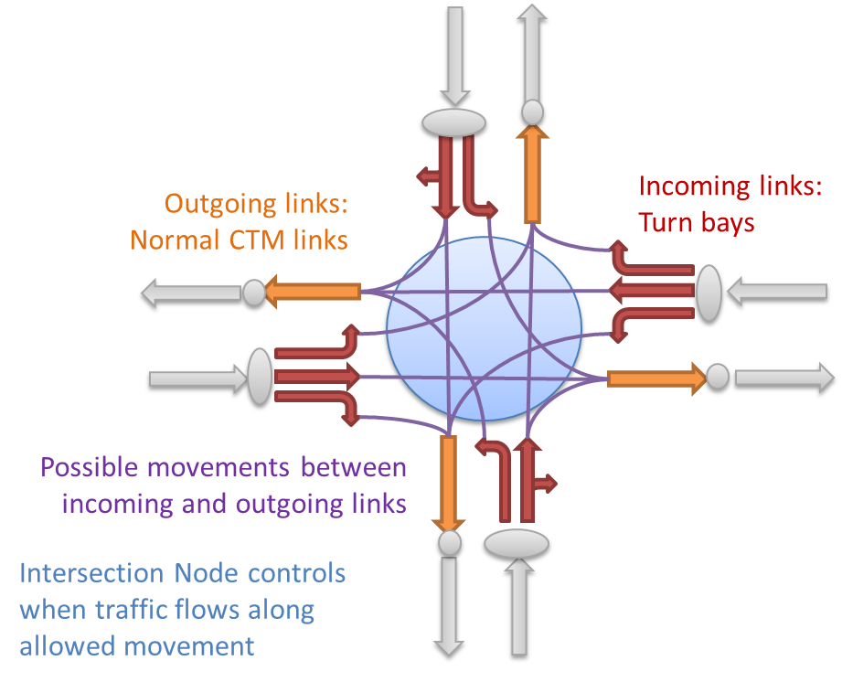
Figure 2: Network topology at a typical 4-leg intersection
The network topology at an intersection reflects the possible traffic movements, as illustrated in Figure 2. At incoming approaches, each physically existing turnbay is modeled as one or more separate links. Each outgoing egress is modeled as one link. Traffic flow through an intersection is decomposed into multiple streams. Typically, at an intersection with four approaches and three allowed movements per approach (left, through, right), twelve movements are possible. Each of those twelve movements translates into a pair of an incoming link and an outgoing link. When the modeled signal of a link pair is red, no traffic flows between the links. When the signal is green, traffic flows between the links as specified by the Godunov scheme.
The simulator is capable of reproducing a fixed-time signal plan, i.e., it repeats the same green-yellow-red sequence in each cycle. It is parameterized by the cycle time and the offset. For each phase, the time step when the signal turns from green to yellow (i.e., force-off time) is specified. Furthermore, yellow clearance and all-red clearance times are specified. To connect the phase with the network, each phase is related to one or more link pairs. The simulation of the traffic signals is accurate to the global simulated time step length $ΔT$. An example of modeling a specific intersection (Huntington & First) is shown in Figure 3:
Figure 3: Example of a signalized intersection: network topology, satellite view, and phase diagram
Technical note: Since the intersection node is connected to many incoming and outgoing links, the split ratio matrix is relatively large. At a typical 4-leg intersection with turnbays for each movement (i.e., 12 incoming links), the split ratios are defined in a 12-by-4 matrix. Since many movements are not allowed (i.e., turning left from a right turn bay), many entries are zero. Furthermore, a split ratio is also defined at upstream nodes corresponding to the beginning of each turn bay.
Implementation limitations: The 2014 implementation of the signalized intersection model was limited to fixed-time signals with no vehicle actuations. In addition, some movements, such as permitted left-hand turns, were not modeled. Intersection modeling will be expanded in future AMS phases.

Ramp meters
The simulator is capable of reproducing the effects of ramp metering. A ramp meter effectively reduces the inflow onto the freeway, which may cause a queue to form on the on-ramp that spills back and potentially affects nearby arterial traffic. The simulator supports fixed-time ramp meters and reactive ramp meters, which adjust the rate according to the traffic state on the freeway.
Although the red and green states are represented directly, it is the average metering rate that is imposed during the simulation, which effectively enforces a cap on the supply function. This behavior is different than that of the intersection signals in which the stop and go (during phases of red and green) is explicitly imposed.

Performance measures
The CTM simulation model can be run to produce measures of traffic flow, speed, and density. From those simulation results, the following performance measures are calculated:
- Vehicle miles traveled (VMT). VMT is the total distance traveled by all the vehicles in the specified area and time period. This metric is representative of the demand of vehicles using the network. This value is calculated over individual links ($l$) and simulation times ($t$) in the network and then summed over the spatio-temporal region of interest ($R$). In the following equation, $q_{l}(t)$ represents the out flow of link $l$ at time $t$, ${Δx}_{l}$ represents the link length, and $Δt$ represents the simulation time step.
$${VMT}_{l}\left(t\right)=q_{l}(t){Δx}_{l}Δt$$
$${VMT}_{R}=\sum_{l,t∈R}{{VMT}_{l}\left(t\right)}$$
- Vehicle hours traveled (VHT). VHT is the total time spent by all the vehicles in the specified area and time period. This value is also calculated over individual links ($l$) and simulation times ($t$) in the network and then summed over the spatio-temporal region of interest ($R$). In the following equation, $ρ_{l}(t)$ represents the density of link $l$ at time $t$.
$${VHT}_{l}\left(t\right)=ρ_{l}(t){Δx}_{l}Δt$$
$${VHT}_{R}=\sum_{l,t∈R}{{VHT}_{l}\left(t\right)}$$
- Travel time. Travel time is the experienced travel time along specified path when entering at time $t$. This value is first calculated over individual links $l$ at entry time $t$. Then it is summed over links of a given path, and then averaged over specified time period. The travel time over a link is calculated as follows:
$$T_{l}\left(t\right)=\underset{τ}{argmax}\left\{\sum_{τ^{'}=0}^{τ-1}{V_{l}\left(t+τ^{'}\right)Δt}≤{Δx}_{l}\right\}$$
- Delay. Delay is calculated as extra travel time (compared with free flow speed) over a spatio-temporal region of interest. Similarly, this value is calculated over individual links ($l$) and simulation times ($t$) in the network and then summed over the spatio-temporal region of interest ($R$).
$$D_{l}\left(t\right)={VHT}_{l}\left(t\right)-\frac{{VMT}_{l}\left(t\right)}{V_{l}}$$
$$D_{R}=\sum_{l,t∈R}{D_{l}\left(t\right)}$$
- Average speed. The ratio between VMT and VHT equals the average speed for the section length and the simulation time.
$$avgSpeed=\frac{{VMT}_{R}}{{VHT}_{R}}$$
- Travel time benefits. When evaluating travel time benefits associated with a particular intervention, we assume a value of time according to the Cal-B/C Corridor 5.0 defaults.
$$travel time benefits=[VHT\left(intervention scenario\right)-VHT\left(no intervention scenario\right)]*value of time$$
- Travel time reliability benefits. Travel time (TT) is reliable when users generally experience what they expect, and do not have to plan extra time for their trips. Travel time reliability can be quantified through several metrics including a buffer-type index or the standard deviation of travel time.
In the AMS effort the 95th percentile travel time is used:
$$travel time reliability benefits=[95\text{th} percentile travel time(no intervention simulation)-95\text{th} percentile travel time(intervention simulation)]*value of time$$
Since the frequency of incidents is typically more than 5% for this simple analysis, the travel time distribution is binary and the 95th percentile travel time is, in this case, the travel time of the incident scenario, with or without intervention. As the range of models and simulations increases, a more representative collection of travel times will be developed.
- Vehicle operating cost savings. The vehicle operating costs depend on VMT and the fuel consumption rate. The fuel consumption rate depends on the speed of the vehicles. This leads to the formula for vehicle operating costs calculation:
$vehicle operating costs=$ $VMT*\left(fuel consumption rate\right)*\left(fuel price\right)$
$vehicle operating cost savings= vehicle operating costs \left(intervention simulation\right)-vehicle operating costs \left(no intervention simulation\right)$
- Emission cost savings. The emission costs depend on VMT and emission rate. This leads to the formula for emissions calculation:
emissions costs = VMT * [(emission rate for CO) * (emission price for CO)
+ (emission rate for CO₂) * (emission price for CO₂)
+ (emission rate for NO₂) * (emission price for NO₂)
+ (emission rate for PM₁₀) * (emission price for PM₁₀)
+ (emission rate for SO_{X}) * (emission price for SO_{X})
+ (emission rate for VOC) * (emission price for VOC)
emissions cost savings = emissions costs (intervention simulation)
– emissions costs (no intervention simulation)

